1
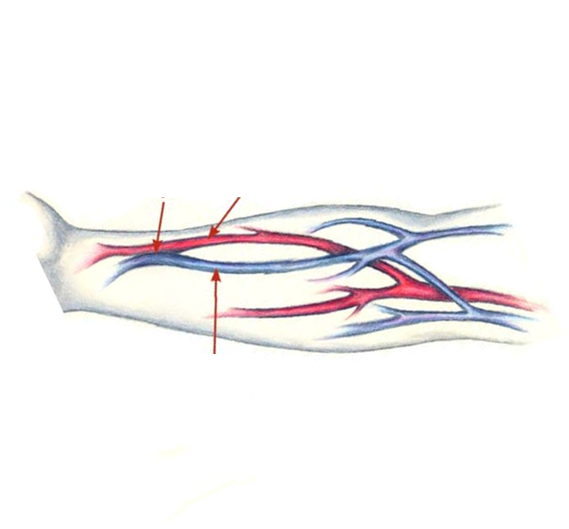

1-diagnosis: AV fistula
2- causes:……..
3-test used to diagnose: !!!!!
4-
5-

2
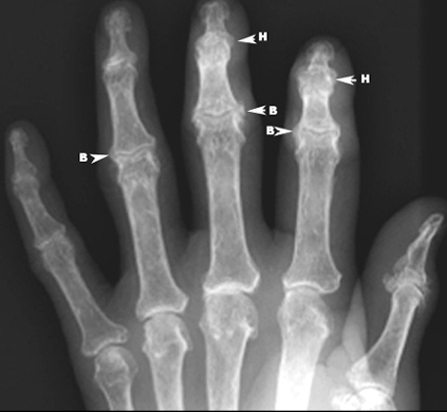
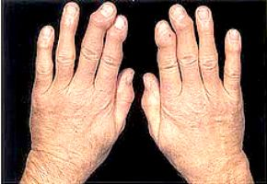

The station was a little confusing: typical story of RA but images of OA and and asked about Bouchard’s and Heberden’s nodules !!! >>

3
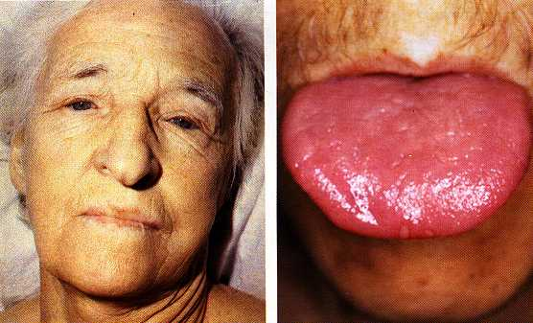

It found in 6th 2009
………….
They were just 4 stations I don’t remember the 4th 555555555
About the dynamics
1-communication about GERD
2-Asthma with dr.Zaqout
3-flouconazole liver toxicity with dr.Qishawi
4-AS with alaa naim
…..
On the other groups I remember that there was AF with Ashraf Shath!!!

