1. [Page 405] When making a 911 call, what are the three W’s?
J Who, What, Where
B Where, What and Why
C Why, When and Where
D Who, What and When
2. [Page 402] What is first aid?
A Completing a primary survey
J The first help given to the victim of an accident
C Assessing a victim’s vital signs
D Treating a victim for shock
3. [Page 405,411,413] What treatment does a victim who’s life threatening condition is “not breathing”
need?
A The Heimlich Maneuver, two rescue breaths and CPR
B Start CPR immediately
C Twelve to fifteen rescue breaths per minute and correct CPR
J You should follow the steps for rescue breathing
4. [Page 407] The best treatment for all heart attack victims is immediate CPR.
FALSE
5. [Page 407] Sharp, stabbing twinges of pain in the chest is a sure sign of a heart attack.
FALSE
6. [Page 437] The accepted treatment for a femor or thigh fracture is:
A Place a short padded splint on each side of the leg
J This type of fracture is best handled by a traction splint applied by those with special training
C Move the victim before properly applying a leg splint
D Bind both legs with two long splints using two cravats, one above and one below the break
7. [Page 426] The victim of a poisonous snake bite is not at risk for getting rabies.
TRUE
8. [Page 424] Some people are very allergic to insect bites and stings. This condition is called:
A Septic shock
B Cardiac arrest
C Toxic shock syndrome
J Anaphylactic shock
اسئلة مراجعة لمادة الاسعافات الاولية

الاجابة الصحيحة عليها رمز J
اسئلة الصح وخطأ مجاوبين

9. [Page 424] A small animal that is almost invisible, burrows into the skin and causes itching:
A Common wood tick
B Limon-Lyme tick
C Rocky mountain spotted tick
J Chigger
10. [Page 423] The accepted treatment for a sprained ankle is:
A Remove the shoe and check for swelling using the capillary reflex method
J Keep the shoe on, apply an ankle bandage for support, elevate and apply cold towels
C Keep the shoe on, apply an ankle splint and apply heat if possible
D Have the victim walk or move as soon as possible to prevent stiffness
11. [Page 420] The accepted treatment for a nose bleed is:
A Use direct pressure, elevation and pressure points to control the bleeding
B Tilt the head back and tightly squeeze the nostrils
J Have the victim lean forward. Apply gentle pressure on the nostril. Apply cold towels.
D Lay the victim on his back and treat for shock. Apply heat if available
12. [Page 402] What is the best definition of the “Hurry Cases”?
A Breathing, bleeding and broken bones
J Any condition that threatens a victim’s life
C Any illness where the victim vomits
D Any accident requiring rescue breathing
13. [Page 402] After you have surveyed an accident scene and provided for your own safety you should:
J Take charge, remain calm and act with confidence to the level of your training
B Provide primary treatment for shock
C Call 911 or your local emergency number
D Provide immediate treatment for the “hurry cases”
14. [Page 410,416] It is not necessary to determine if a person with an obstructed airway has a pulse.
TRUE
15. [Page 420] To treat a first degree burn you should:
A Apply a good quality burn cream or ointment
B Clean the area thoroughly with hot soapy water
C Apply a constricting band between the burn and the heart
J Apply cool running water until there is little or no remaining pain
16. [Page 429] A victim that has come in contact with poison ivy should:
A Wait at least 20 minutes before washing the effected area with hot water and soap
J Rinse the effected area immediately with soap and water
C Continue to ware clothes that have come in contact with the plant
D Immediately scratch and rub the effected area to provide long-term relief from the itching

17. [Page 438] Which of the following techniques is not suitable for moving an unconscious victim?
A Improvised stretcher
J Four-handed seat carry
C Two person carry
D Blanket drag
18. [Page 441] Assuming you are properly trained, the best procedure to follow for a water rescue is:
A Throw, row then go
J Try to reach from the shore, then throw a rope or rescue device, last go with support
C Swim with support, throw a rope or flotation device, reach with a pole from shore
D Reach, paddle, swim
19. [Page 434] What is the appropriate treatment for a suspected broken collarbone or shoulder?
J Apply a simple sling. Bind the sling to the chest with a cravat
B Use the cross your heart padded chest support method
C Use the flail chest protection system
D Apply a modified “Johnson Traction Splint”
20. [Page 433] Which statement about a simple sling is true?
A The part of the sling against the chest goes over the shoulder on the injured arm
B The “pigtail” protects the neck from injury from the sling
C The injured hand should be four to six inches higher than the elbow
J The part of the sling furthest away from the chest passes over the shoulder on the injured arm
21. [Page 430] White or grayish-yellow patches on someone’s ears, noses or cheeks are signs of
J Frostbite
B Cold related stress disorder
C Anaphylactic shock
D Hypothermia
22. [Page 431] The primary symptom of the advanced stages of hypothermia requiring immediate
medical attention is violent shivering.
FALSE
23. [Page 429,430] The symptoms of Heat Stroke and Heat Exhaustion are very similar and are often
confused.
FALSE
24. [Page 412,413] Which of the following correctly describes the CPR technique for an adult:
A Four cycles of 15 compressions followed by 1 breath each minute
B One cycle of one breath and 10 compressions each 2 to 3 inches deep per minute
C Twelve cycles of one breath and 5 compressions per minute
J Four cycles of two breaths and 15 compressions per minute

25. [Page 426] What is the best procedure for treating a known poisonous snake bite?
A Capture the snake. Place it in an ice chest and take the snake and victim to a hospital.
B Place a constricting bandage 4 inches above the head of the snake to slow the spread of venom
J Keep the victim calm, keep the bite location lower than the heart, get medical help immediately
D Treat the victim for shock and continue the planned activity
Tie Breaker Questions
[Page 414] Severe bleeding is a “hurry case.” Which one of the following statements is TRUE:
A Bleeding can seldom be stopped with direct pressure
B A tourniquet is almost always required to control serious bleeding
C Should the first sterile pad used become blood soaked, immediately remove it and apply another
J Try to avoid direct contact with the victim’s blood by using latex gloves or another barrier

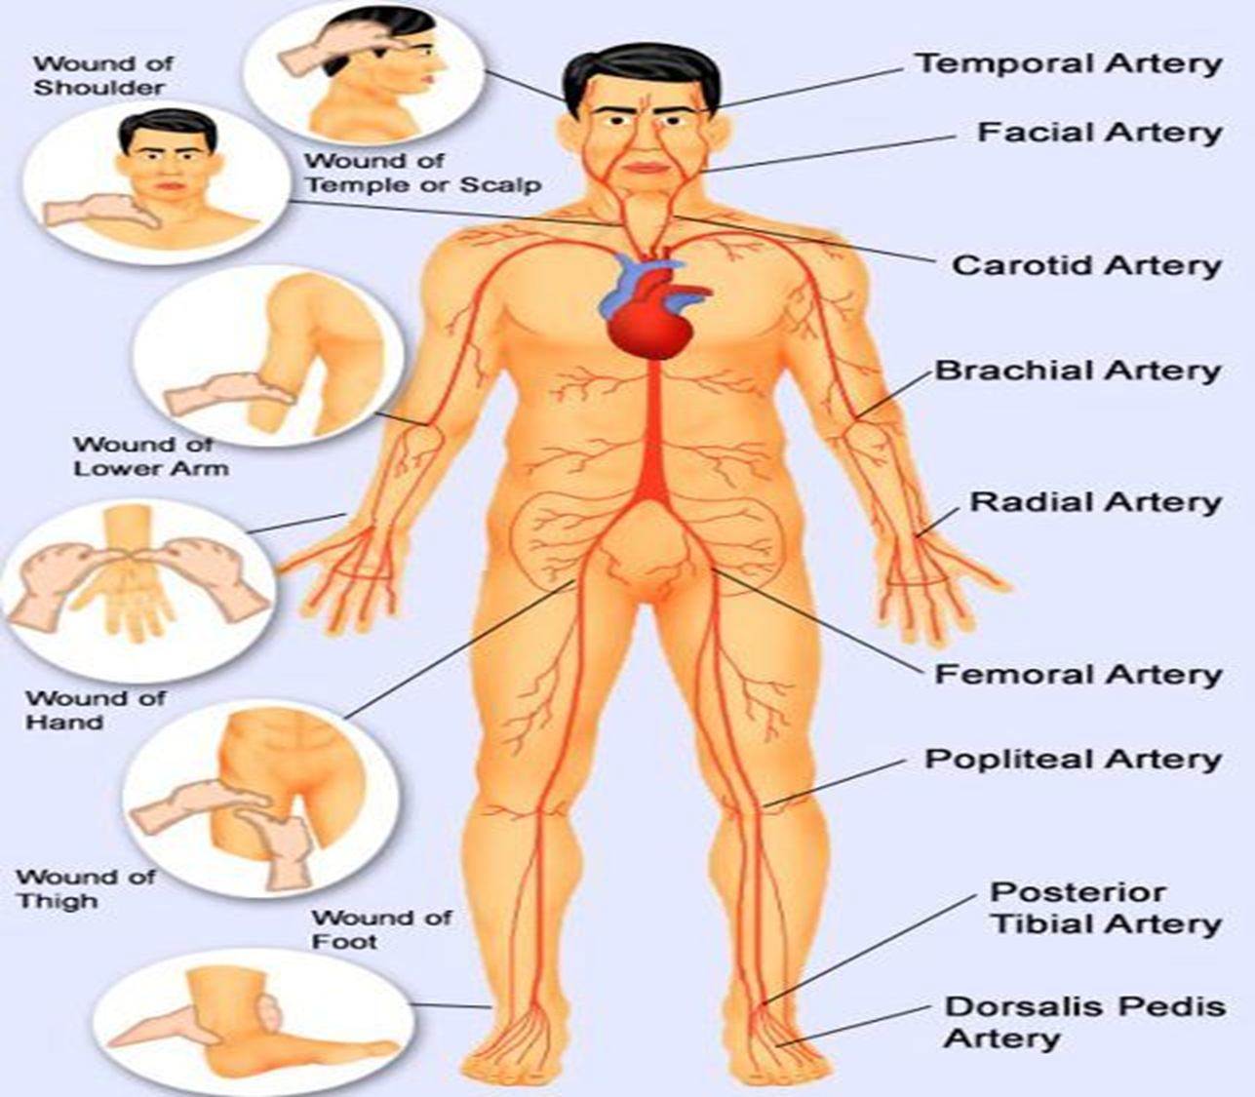
- Occasionally, in major limb injuries such as partial amputations and shark attack , severe bleeding cannot be controlled by direct pressure.
- Only then, it may be necessary to resort to the application of a constrictive bandage above the elbow or knee.
- Select a strip of firm cloth, at least 7.5 centimetres (3 inches) wide and about 75 centimetres (30 inches)long. This may be improvized from clothing or a narrow folded triangular bandage.
- Bind the cloth strip firmly around the injured limb above the bleeding point until a pulse can no longer be felt beyond the constrictive bandage and bleeding is controlled. Tie firmly.
- Note the time application. After 30 minutes, release tje bandage and check for bleeding . If there is no bleeding, remove it .If bleeding recommences, apply direct pressure. If this is unsuccessfully, reapply the constrictive bandage, and recheck every 30 minutes.
- Ensure that the bandage is clearly visible and inform medical aid of the location and time of its application.

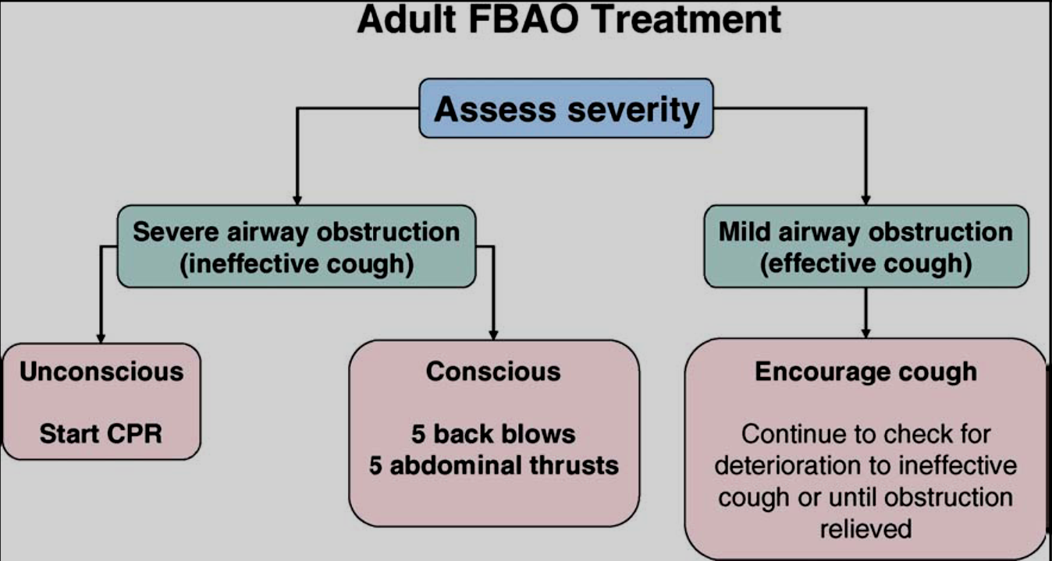
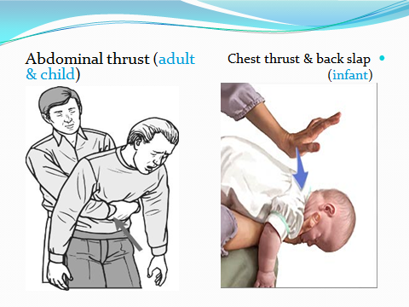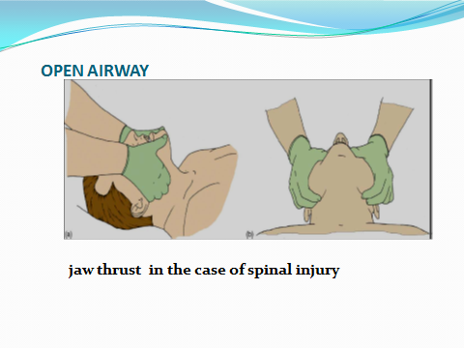
Thing to do in CPR
- Make sure the quality of CPR is good!
- More important: the chest compressions!
- Minimize time with no chest compressions (”hands-off-time”)
- 30 chest compressions : 2 MTM
- Rate 100 min⁻¹
- Depth 4-5 cm
- Equal compression : relaxation

